A Party on the Moon
To- Jimmy Bob Heron
Where?
This party will be on the darkest side of the Moon.
Start Time:12noon End Time:9pm
Date: 9th February 2022
What we are going to do?
We will play space games, walk about and a go on the space buggy.
What do you need to bring?
You will need a space suit and oxygen.
How do we get there?
We will meet at Paddington Station in London on Apollo 29.
RSVP: Ring or text 012345678910
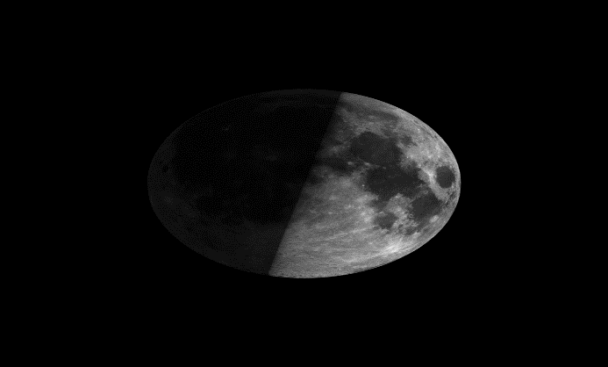
From: Billy Bob O’Kane

