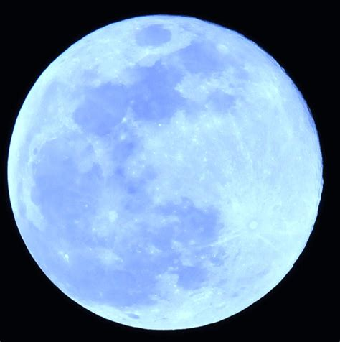
An Exciting Trip to the Moon.

To - The Carl and Carly Cube family.
Where? A tour around the moon.
Start and End Time- It will start at 1pm and will end after one week.
Date – December 29th
We are going bungee jumping and moon buggy riding,
You need to bring - clothes and a space suit. Don’t forget £55.00.
We are leaving - from NASA.
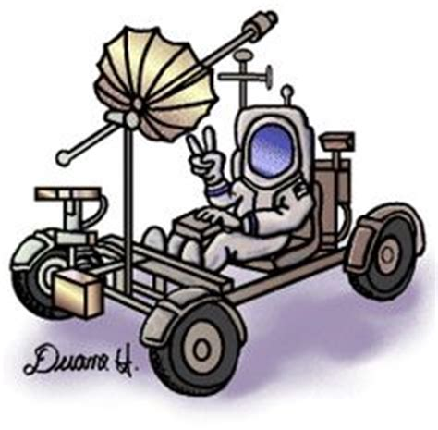
From - JJ Jack John.
RSVP – Mr JJ Jack John.

