An Invitation to a Party on the Moon

To Jim Bob Billy Bob Bob.

Where is it? It is in the middle of The Moon.

Time- 3pm to 6pm

Date - 1st December 2018
We will be partying and playing with Alien’s, going on Moon buggies and jumping around.
You will need to bring a big space suit and an oxygen tank.

You will need to travel to the International Space Station and then we will bring you to The Moon on a rocket.

RSVP- Contact Mr Cheetos 999421

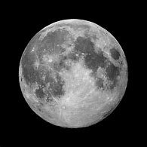
From Mrs and Mr Cheetos.

