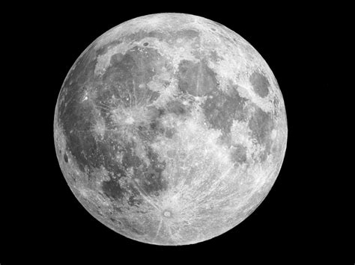
An Invitation to a Party on the Moon!!!
To - Zach and Noah McCahon.
Where? This party takes place in the second, largest crater on the light side of the moon.
Start time – This party will start on the 17th of March 2019 at 4:00pm
End time – This party will end on the 23rd of March 2019 at 7:00pm
Date – 17th of March 2019 – 23rd of March 2019
What are we going to do? We are going to eat lots of sweets, make moon angels, ride a moon buggy and explore the moon.
What do you need to bring? You’ll need to bring extra sweets, oxygen, a space suit and some spare food in case of an emergency.
How do you get there? You’ll get to the moon by entering the rocket that is at Meadowbank Sports Centre.
R.S.V.P – Please contact the alien Joan Banannacle.
From – Brother eating Frogle Frog Banannacle.

