An Invitation to a Party on The Moon.
Start Time –Midnight End Time:4.30am
Date – 15th December 3017
What are we going to do? We are going to glide around the planets.
What do you need to bring? Oxygen, Space suit and a jetpack.
How do you get there? Apollo 1060
Where are we leaving from? NASA Space Centre
RSVP- Contact Ricky Dee’s mum
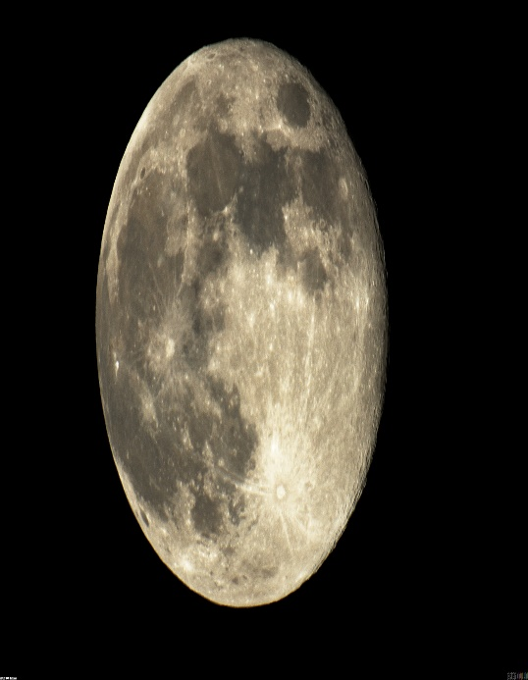
From Ricky Dee

