An invitation to the moon

To-Mr McNamee
Where-On the biggest crater on the moon.
Time - 2 o’clock to 9 o’clock.
Date - 13th to 15th December 2025.
What are we going to do? We are going to do a moon jumping, searching for the first American flag and moon rocks.
What do you bring? You will bring your own spacesuit and food.
Where are we leaving from? Matthew’s house.
RSVP-Sarah Robinson 12455164580.
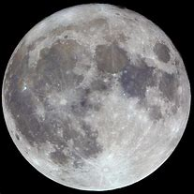
From Sarah and Matthew

