Introduction to Seesaw
Dear parent we will be using Seesaw to upload homework w/c 28 September and we will also use this forum should a class have to isolate during this pandemic. I have provided an overview of how to access it below. By now you should all have received a code via email, if you haven’t, contact school immediately. An introductory task has already been set by teachers and should be completed by 22 September.
Either google Seesaw or type in app.seesaw.me
You will see the screen below

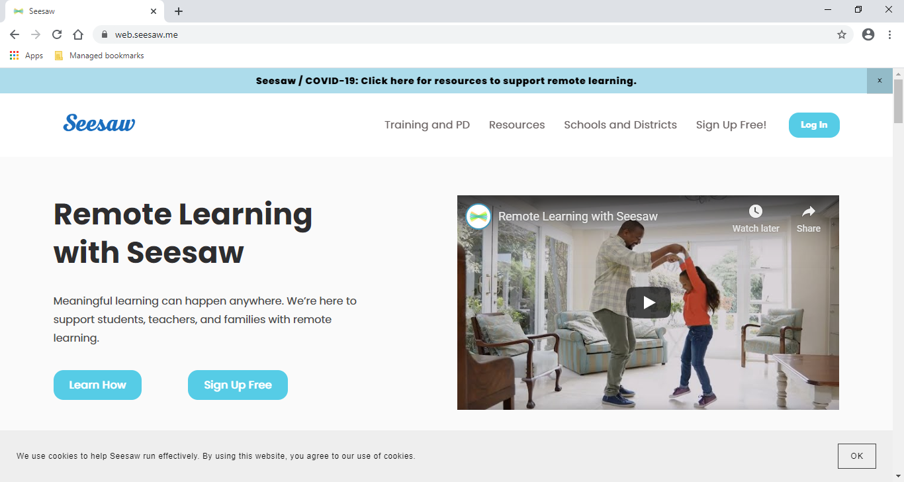

Click log in
Click log in
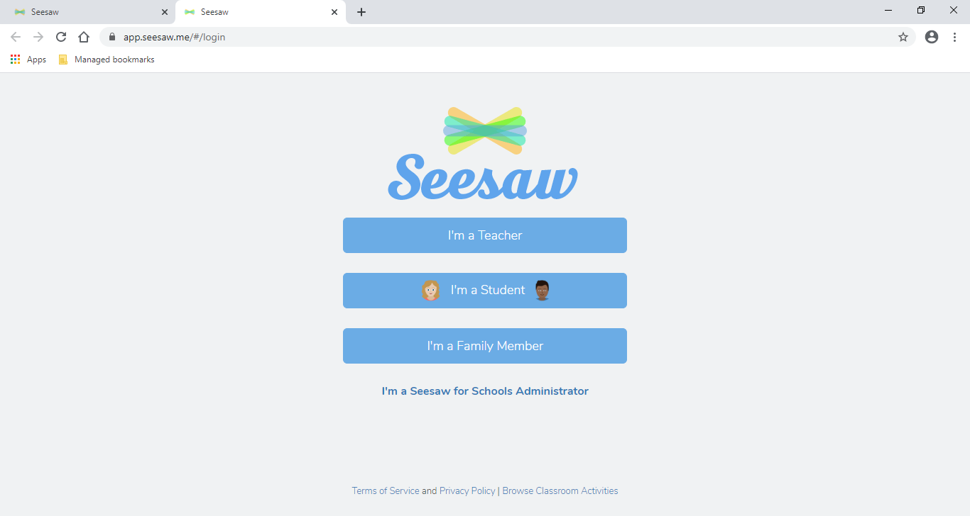
Click I’m a student

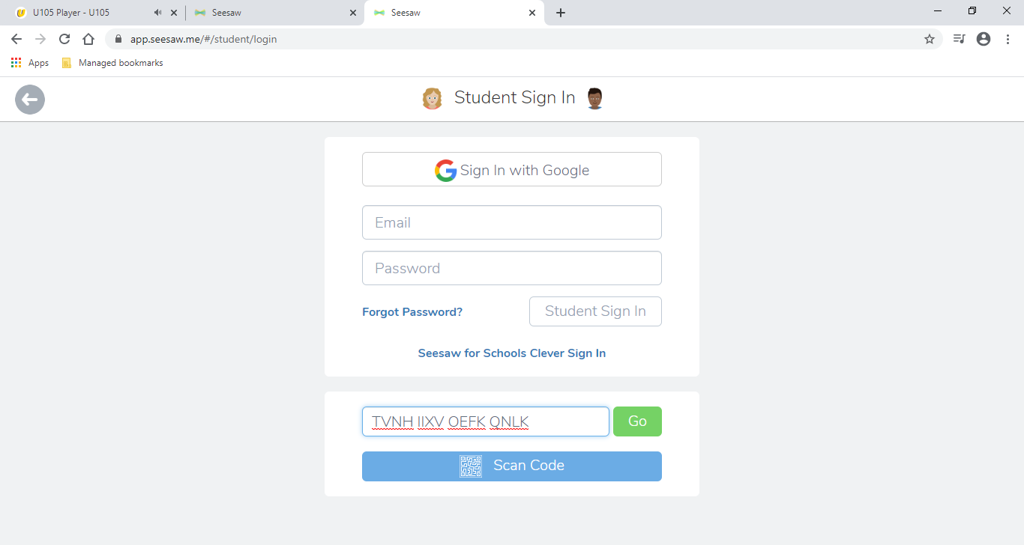
Type in your code and click ‘Go’

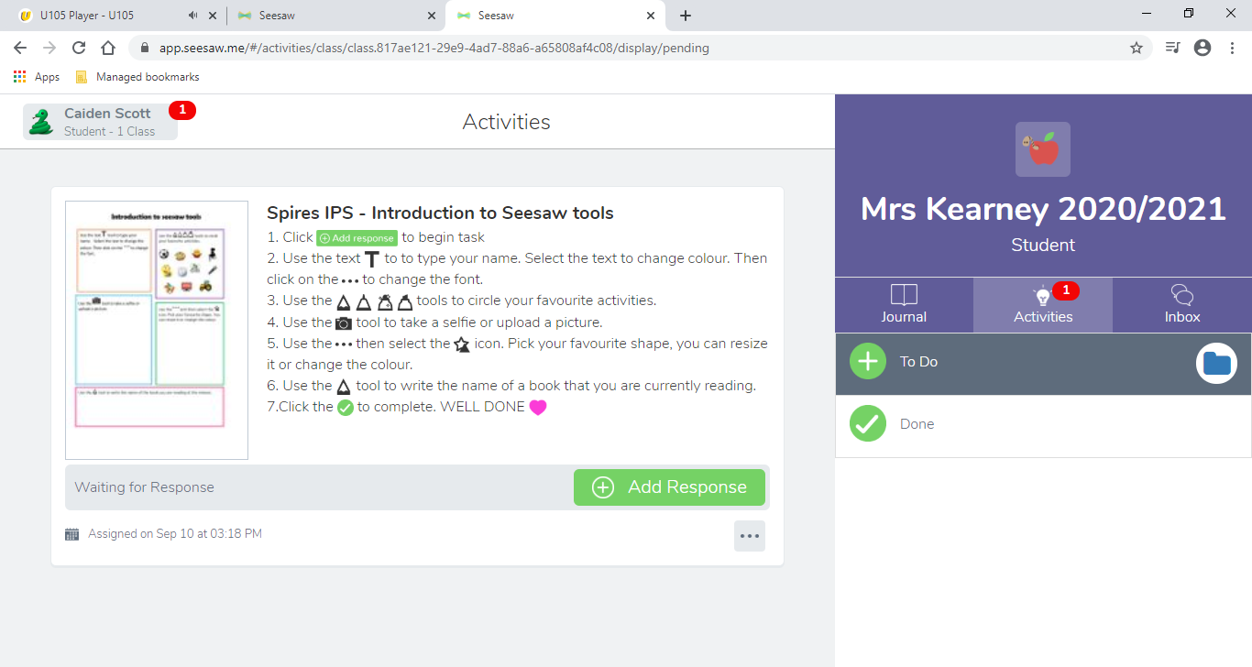
Your teacher’s name is shown here
This is your first activity
Your name appears here

