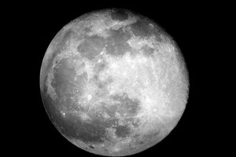
A Party on the Moon
To: Jimmybob Billybob Bob
Where? In the BIGGEST crater.
Time? 6:00am – 11:59pm.
Date? 30th of April 2019.
What are we going to do? Do backflips, do handstands, dab and make moon angels.
What do you need to bring? A spacesuit and oxygen.
Where are we leaving from? Abigail McNally’s house.
RSVP? Call Jimmybob Billybob Bob’s phone at 123456789.
From: Fun Time Freddy.

