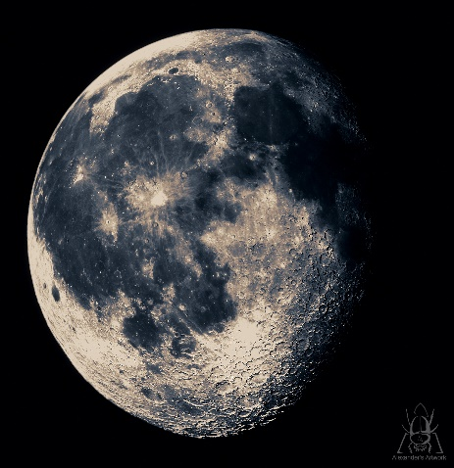
A Party on the Moon

To – Bobalena Bob
Where? The party is on the big moon in the sky.
Leaving Earth? The leaving time is at 6pm.
When we leave the Moon? We will leave the moon at 1am.
Date? The date is 1st of January 2019.
What are we going to do? We are going to ride space buggies and play space games.
What you need to bring? You need to bring your own space suit and oxygen.
How do we get there? We will leave NASA space station on Apollo 505.
RSVP- You will need to contact Mrs Millar or Mrs Bayne.
From- this is from Heidi and Pippa.

